- Go to https://docs.google.com/forms/u/0/.
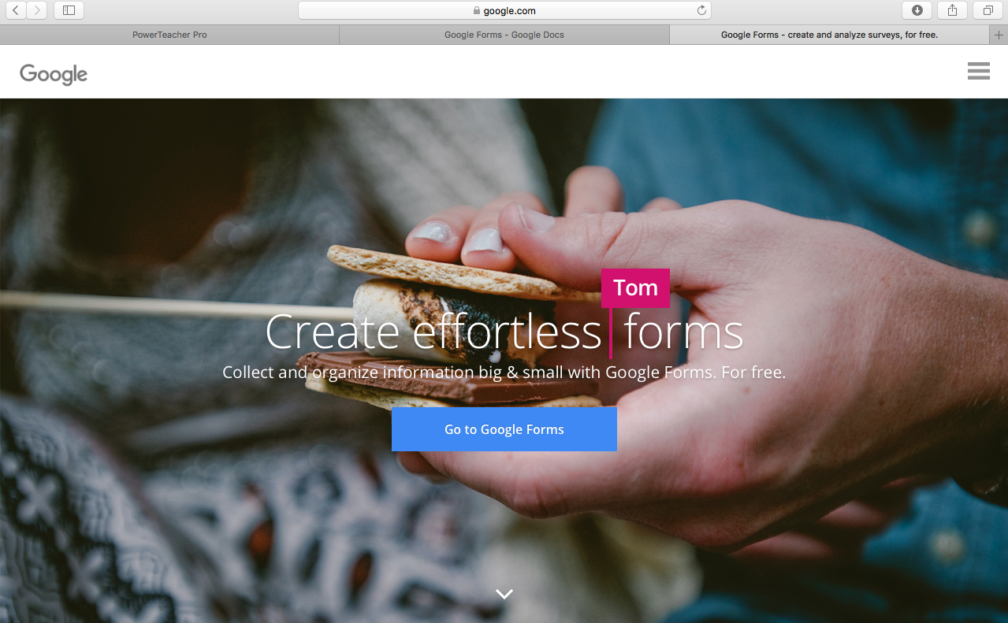

Creating a Quiz:
- Click on create a blank form.
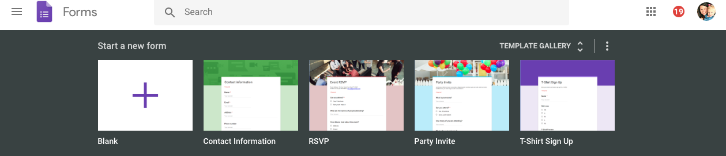

2.Give your form a title.
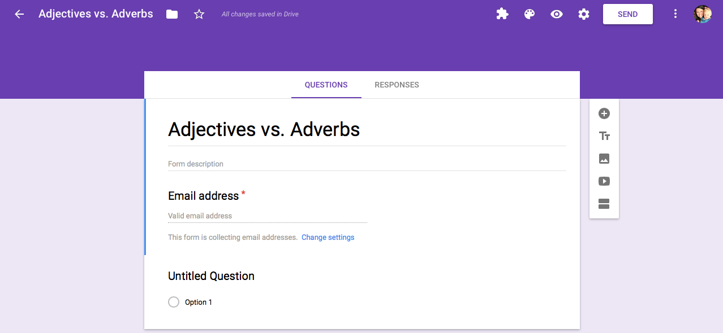
3. Go to the top and click on the gear icon which is the settings. From here a popup box will show and click on the word quizzes on the top header. Switch the toggle to transform the form into a quiz and press save.
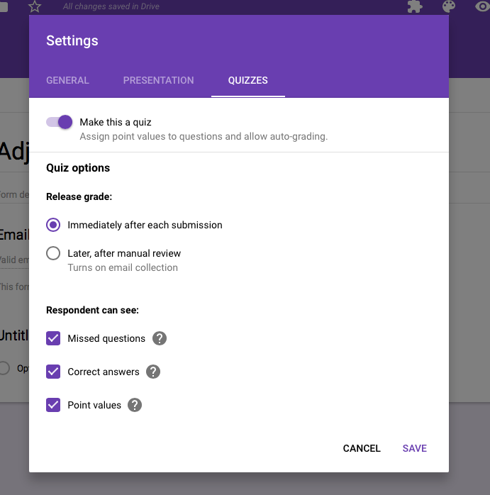

- Optional:
- Change the heading, theme, font, and background color.
- Add a description of the form.

Adding Questions
- Add a question by clicking on untitled question and choosing the type of question you would like to ask: Short answer, paragraph, multiple choice, checkboxes, dropdown, file upload, linear scale, multiple choice grid, checkbox grid, date, and time.
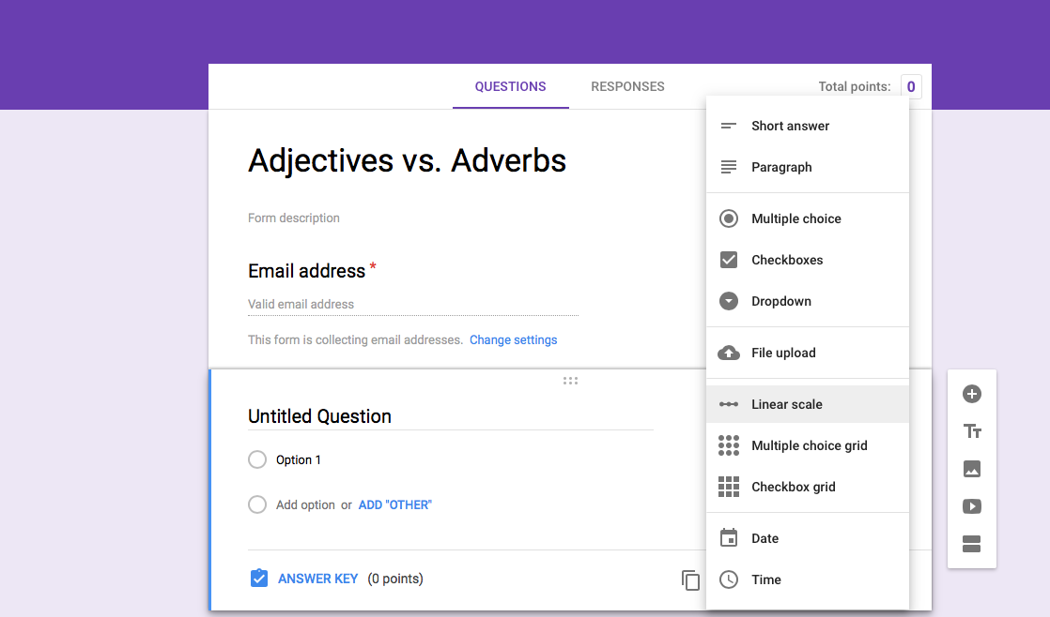

- Add answer choices to your question if they are needed.
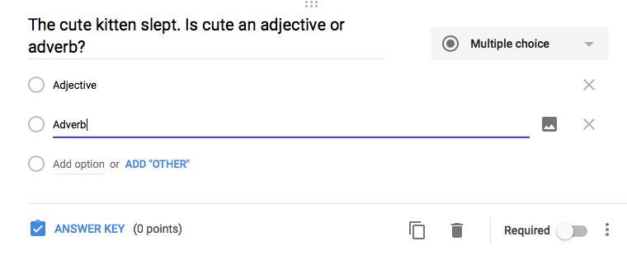

- Click on Answer Key and add correct answers to the question. Give the question a point value so students know how much it is worth.
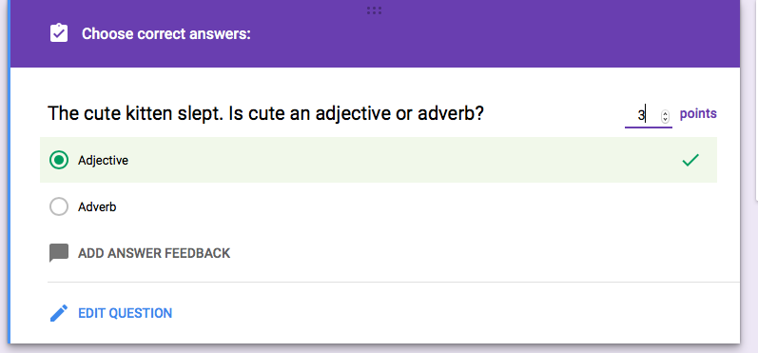

- Optional:
- Click if the question is required to be answered.

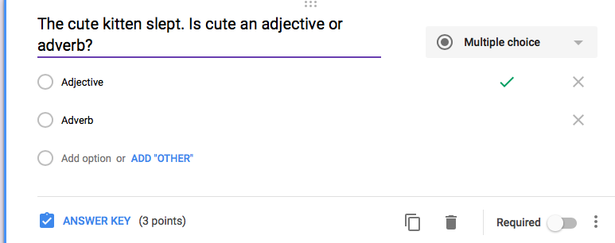
- To add a new question click on the add question plus +. To duplicate a question click the duplicate icon.
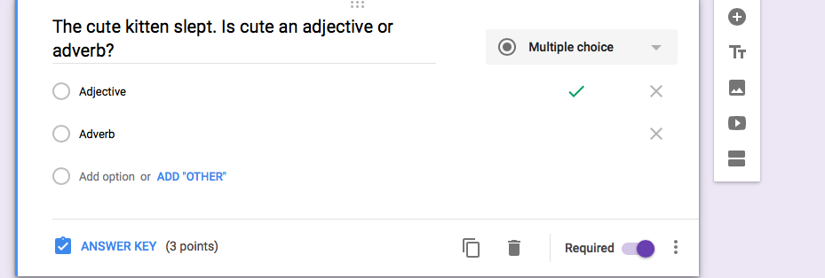

Sending the Quiz:
- When your quiz is ready to be sent to students, click send in the top right corner.

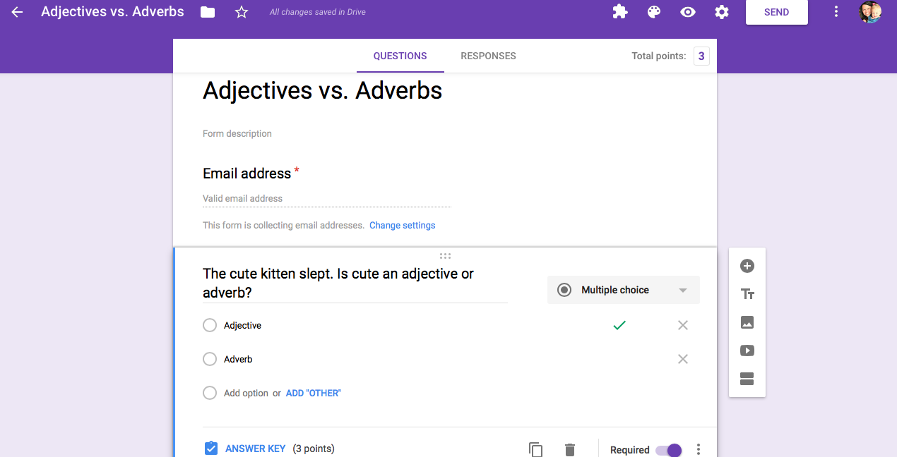
- Quizzes can be sent by email, link, website content, or social media. When using a learning management system that is not compatible with Google, copy and paste the link under an assignment in the LMS.

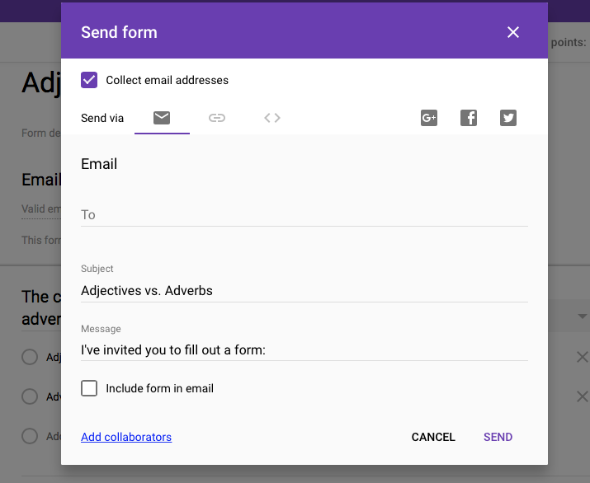
Analyzing Responses:
- When you are ready to analyze response select change the accepting response button to off.
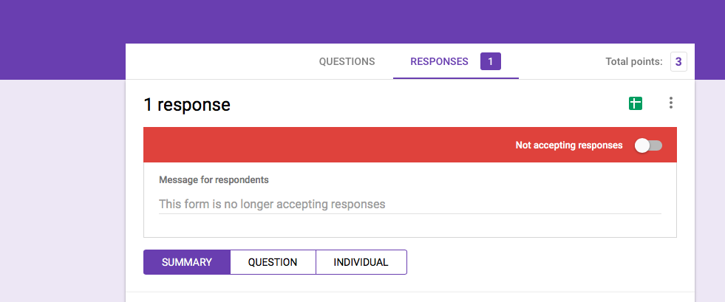

- To analyze your quizzes and get an understanding of how your students did, select the Response tab at the top of your quiz.
- Here you are able to decide if you would like to view your responses as a summary, by question, or by individual student.

